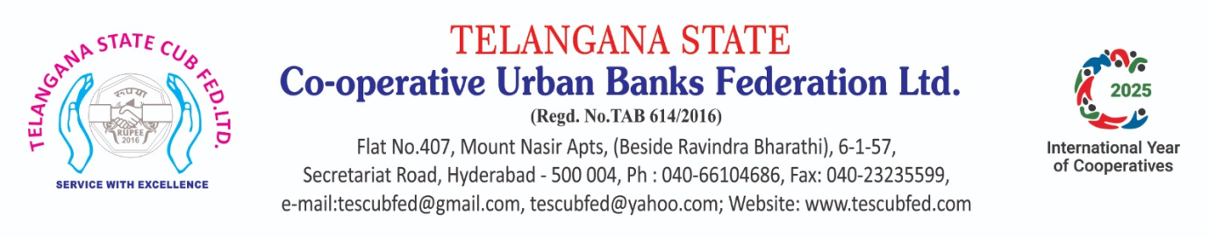
Report:

Training Programme cum Workshop for the Chairmen, Directors, Members of Board of Management, CEOs and Senior Functionaries of Urban Cooperative Banks
13th February, 2026 at Hotel Royalton, Hyderabad

In a powerful synergy with NAFCUB, the Telangana State Cooperative Urban Banks Federation hosted an exclusive one-day Training Programme cum Workshop on February 13th, 2026. Set against the elegant backdrop of Hotel Royalton in Hyderabad, the event served as a high-level forum for the visionaries of the sector—Chairmen, Directors, CEOs, and senior leadership. The atmosphere was one of intense collaboration and insight, drawing a dedicated crowd of 83 elite delegates. The leadership of the Telangana Federation—President Shri Vemireddy Narasimha Reddy, Working President Shri G. Madana Gopala Swamy, and Vice-President Shri Pramod Kumar Kedia—presided over the event, ensuring a day of impactful learning and strategic networking for the future of urban cooperative banking. CEO Shri R. Krishna Murthy welcomed the guest speakers, Chief Guest, Shri K Surendra Mohan IAS garu, Principal Secretary, Agriculture and Cooperation, Commissioner Cooperation and Registrar, Cooperative Societies, Government of Telangana, Guests of Honour, Shri Prabhuti Samal (DGM, DoS, RBI) & Shri Abhishek Kumar (DGM, MoF, CAB, RBI, Pune) , Shri Subhash Gupta (Advisor, NAFCUB) and Shri Anil Chauhan (Program Coordinator, NAFCUB).

In his opening address, President Shri Vemireddy Narasimha Reddy provided a sharp analysis of the evolving landscape of the UCB sector. Highlighting the shift in modern banking paradigms, he urged members to remain vigilant and proactive, equipping themselves with the strategic foresight necessary to navigate emerging challenges. Echoing this call for excellence, Working President Shri G. Madana Gopala Swamy emphasized the critical importance of regulatory precision. He underscored that a thorough mastery of the RBI directives issued from November 28th, 2025, onwards is not merely a requirement, but the cornerstone of strengthening the resilience and integrity of Urban Cooperative Banks.

Chief Guest Shri K Surendra Mohan IAS garu, Principal Secretary, Agriculture & Cooperation, Commissioner Cooperation and Registrar, Cooperative Societies, Government of Telangana delivered key note address. It gives me immense pleasure to address this august gathering and share a few thoughts on the remarkable performance and growing responsibilities of Urban Co-operative Banks (UCBs) in Telangana. Today, the performance of UCBs in Telangana stands as a landmark achievement in the Development of Banking Culture in our state. Over the past three and a half years, we have witnessed extraordinary growth in deposits, advances, profitability, and compliance standards. As on March 2022, the total business of UCBs was around ₹11,500 crores and today, it has grown to nearly ₹19,500 crores. The loan portfolio alone has increased significantly, reaching approximately ₹8,000 crores across the state, with nearly ₹4,500 crores added during this period. This growth is not accidental. It is the result of your dynamic leadership, disciplined governance, and positive community-oriented approach. You are not merely running banks, you are safeguarding nearly ₹11,000 crores of public deposits. These deposits represent the hard-earned savings of common people. Therefore, your responsibility is not small — it is a heavy and noble responsibility. At the same time, you are extending credit to the needy — small traders, Self Help Groups, self-employed individuals, families, and micro-entrepreneurs. Behind every loan sanctioned, there is a family whose livelihood depends on your institution. Through your efforts, employment is generated, businesses are strengthened and future professionals — bankers, IT experts, doctors, and entrepreneurs — are nurtured.
However, growth brings new challenges. Today, competition from commercial banks is intense. Regulatory expectations are aligned increasingly with commercial banking standards. Compliance, capital adequacy, governance norms, and transparency requirements are becoming more robust. Therefore, strengthening capital base, enhancing IT infrastructure, and recruiting skilled manpower are no longer optional — they are essential.
We must also adapt technological transformation. Customers now expect mobile banking, UPI facilities, digital payments, and seamless services. Technology adoption by the public is growing rapidly. If people are ready to adopt digital platforms, we must be equally prepared to provide efficient, secure, and innovative digital banking services. I strongly suggest that UCBs explore the use of Artificial Intelligence (AI) in developmental activities — such as risk assessment, fraud detection, customer service automation, credit monitoring, and data analytics for better decision-making.
Further, succession planning is crucial. We are custodians of these institutions — not permanent owners. The bank must grow beyond individuals. We must induct and train young professionals, build future leadership, and ensure institutional continuity. Governance reforms and responsible director engagement will play a vital role in this journey.
In Telangana, we have more than 25 types of co-operative societies, and the total number of societies exceeds 15,000. The co-operative movement is vast and powerful. UCBs form a crucial pillar within this structure. Your contribution to financial inclusion, local economic growth, and social stability is invaluable.

Let us move forward with a clear vision:
- Strengthen capital and governance.
- Embrace modern technology and AI-driven systems.
- Enhance compliance and transparency.
- Invest in skilled manpower.
- Build future leadership for sustainable growth.
If we work collectively with commitment and foresight, Telangana Urban Co-operative Banks will not only sustain their growth but also emerge as models of resilience, innovation, and trust. Thank you all.
In a session marked by high-level regulatory insight, DGM Shri Prabhuti Samal (Department of Supervision, RBI Hyderabad) commended the Federation’s unwavering commitment to empowering member Urban Cooperative Banks through education. He reaffirmed the Reserve Bank’s continuous support, assuring that the RBI remains a steadfast partner in the growth and stability of the sector.

Over the last two days, I have had the opportunity to closely interact with the Urban Co-operative Banking fraternity of Telangana. I must state with satisfaction that the performance of Telangana UCBs has been commendable not only at the State level but also at the national level. The sector today stands among the best performing in the country — particularly in capital strength, asset quality, profitability and regulatory discipline.
This achievement is not accidental. It is primarily the result of consistent support from the banks, timely submission of regulatory returns, and willingness to align with supervisory guidance. When banks submit data in time, the Reserve Bank of India is able to analyse, advice and correct early. Supervision today is not merely inspection — it is preventive guidance. Our objective is not to penalise but to protect depositors and strengthen institutions.
Urban Co-operative Banks occupy a unique position. Customers approach you because of trust and accessibility. Unlike large private or foreign banks that depend on documentation and systems, your strength is relationship banking. Therefore, our mandate at RBI is clear — the trust of depositors must be protected at any cost. For decades we have ensured stability in the sector, and we intend to continue this stability.
However, I must also emphasise — do not assume that irregularities will remain unnoticed. The monitoring systems of RBI have become technology-driven and continuous. Returns, statements and data submissions are not routine paperwork; they are supervisory signals. They help us understand whether the bank is healthy, stressed, or requires support. Hence timely and accurate submission of returns is a governance responsibility, not a clerical activity.
I appreciate that most Telangana UCBs are now submitting quarterly returns within due dates. This shows maturity and seriousness. Earlier reminders were frequent, but now compliance culture is improving. I urge the remaining institutions also to adopt the same discipline.
Another important area is Cyber Security. Today, customers’ data is their wealth, and banks are custodians of that trust. Shareholders own the bank, but depositors own the confidence of the bank. Therefore, the Board and Top Management must take direct responsibility for information security, technology risk management and digital transaction safety. Cyber risk is not an IT issue — it is a governance issue.
For the convenience of banks, RBI has consolidated master directions and guidance so that operations become smoother and clearer. Compliance should not be seen as burden but as protection for the institution itself.
Going forward, we are also examining a comprehensive evaluation framework for Urban Co-operative Banks — not merely based on deposits and advances, but on capital adequacy, governance standards, compliance behaviour, customer service and return submission discipline. Telangana can become a model for the country in this regard.
I would like to conclude by assuring you — RBI stands with well-managed banks. If issues are reported transparently and early, guidance and support will always be available. Our intention is to strengthen, not to obstruct.
Let us work together to maintain stability, trust and growth in the Urban Co-operative Banking sector.
Building on the theme of institutional integrity, Shri Abhishek Kumar (DGM and Faculty Member, College of Agricultural Banking, RBI Pune) delivered a compelling master class on Corporate Governance that include, Governance is the "paramount parameter" for modern UCBs, directly tied to the landmark RBI Governance Directions issued on November 28, 2025. He advised Board members to focus their expertise on high-level strategic direction and policy-making while strictly avoiding interference in the bank’s daily operational management. Stressing the need for a "hands-off, eyes-on" approach, he emphasized that professional governance is the only way to safeguard the UCBs future.

In an insightful address, Shri Subhash Gupta, Advisor to NAFCUB, highlighted the significant commitment of the Ministry of Cooperation, Government of India, toward revitalizing the UCB sector. He noted that the Ministry is investing substantial resources into these specialized training programs—channeled through NAFCUB—with a clear vision for elevating institutional performance. He urged member banks to embrace the "true spirit" of the initiative, translating the day’s takeaways into actionable strategies for the sustained growth and strengthening of UCBs across Telangana.
Complementing this vision, Shri Anil Chauhan, the Program Coordinator, lauded the Telangana Federation for their seamless execution and meticulous arrangements. He encouraged all participants to diligently apply the knowledge gained, viewing these insights as the essential tools required to drive their respective banks toward a future of excellence and stability.

Concluding the session on a note of gratitude, Vice-President Shri Pramod Kedia extended a sincere vote of thanks to the distinguished panel. He lauded the elite guest officers for their profound insights and the "dedicated action plan" presented, which serves as a vital roadmap for the robust and prosperous future of the sector.

Few photos taken on the occasion are attached for your reference.
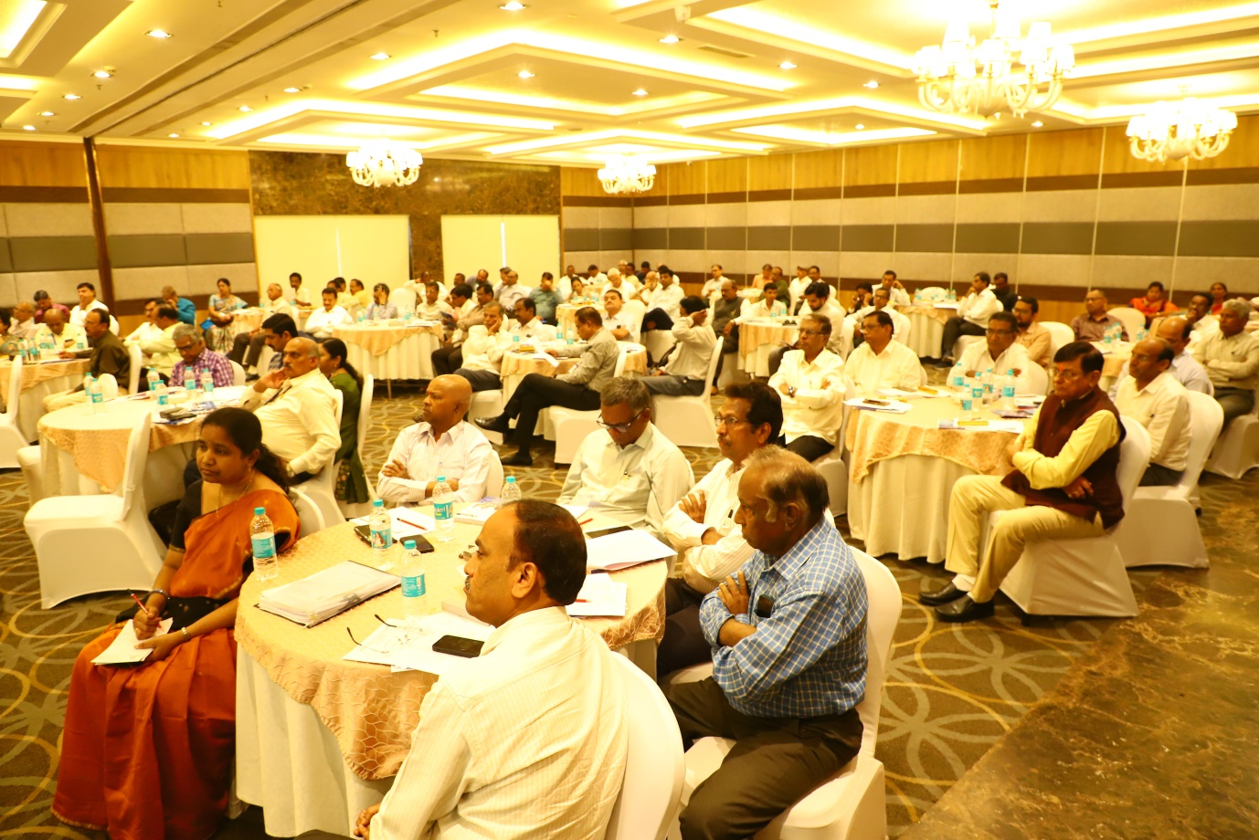
A view of Participants

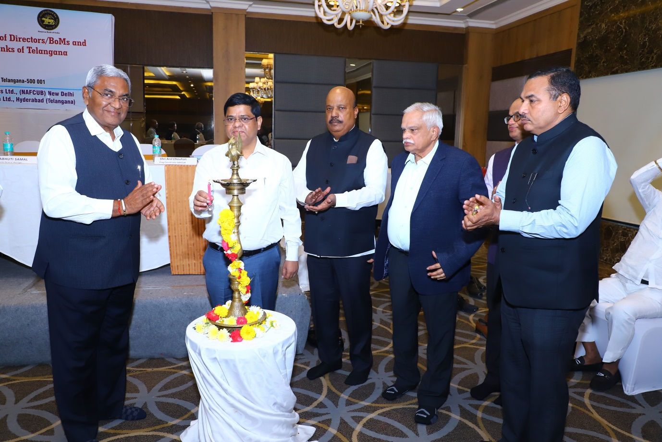
Jyothi Prajwalana - Shri K Surendra Mohan IAS garu, Chief Guest
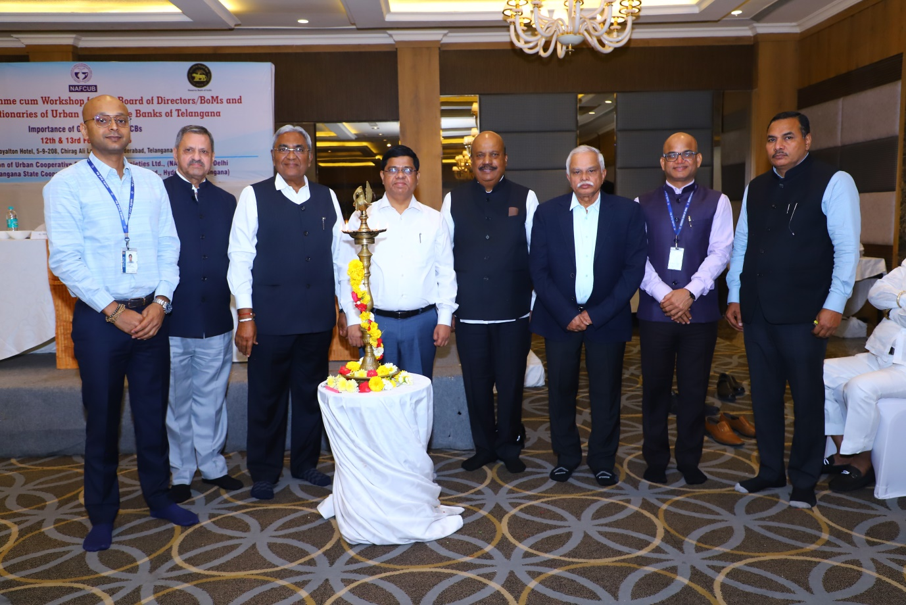

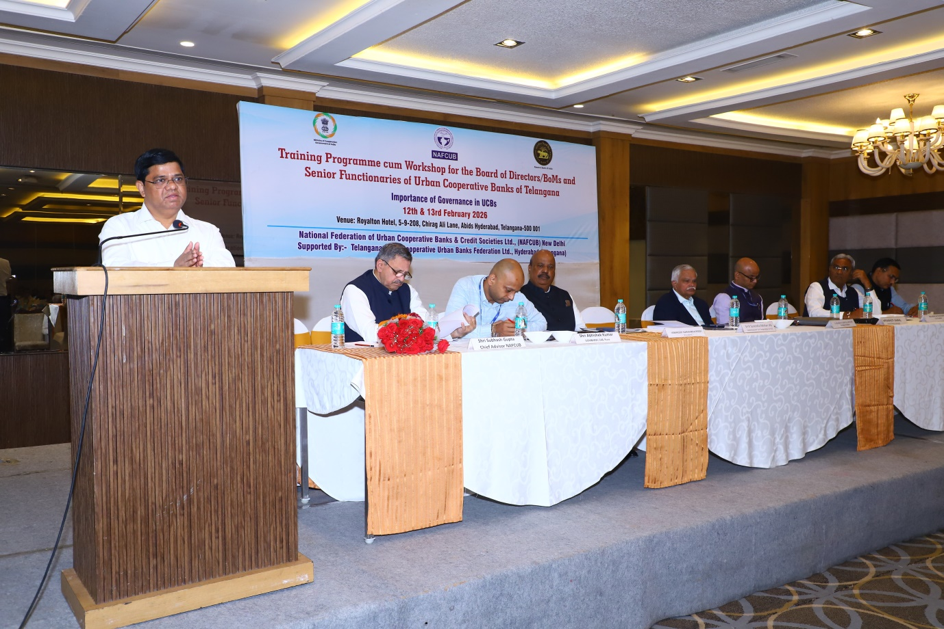
Chief Guest Shri K Surendra Mohan IAS garu Addressing
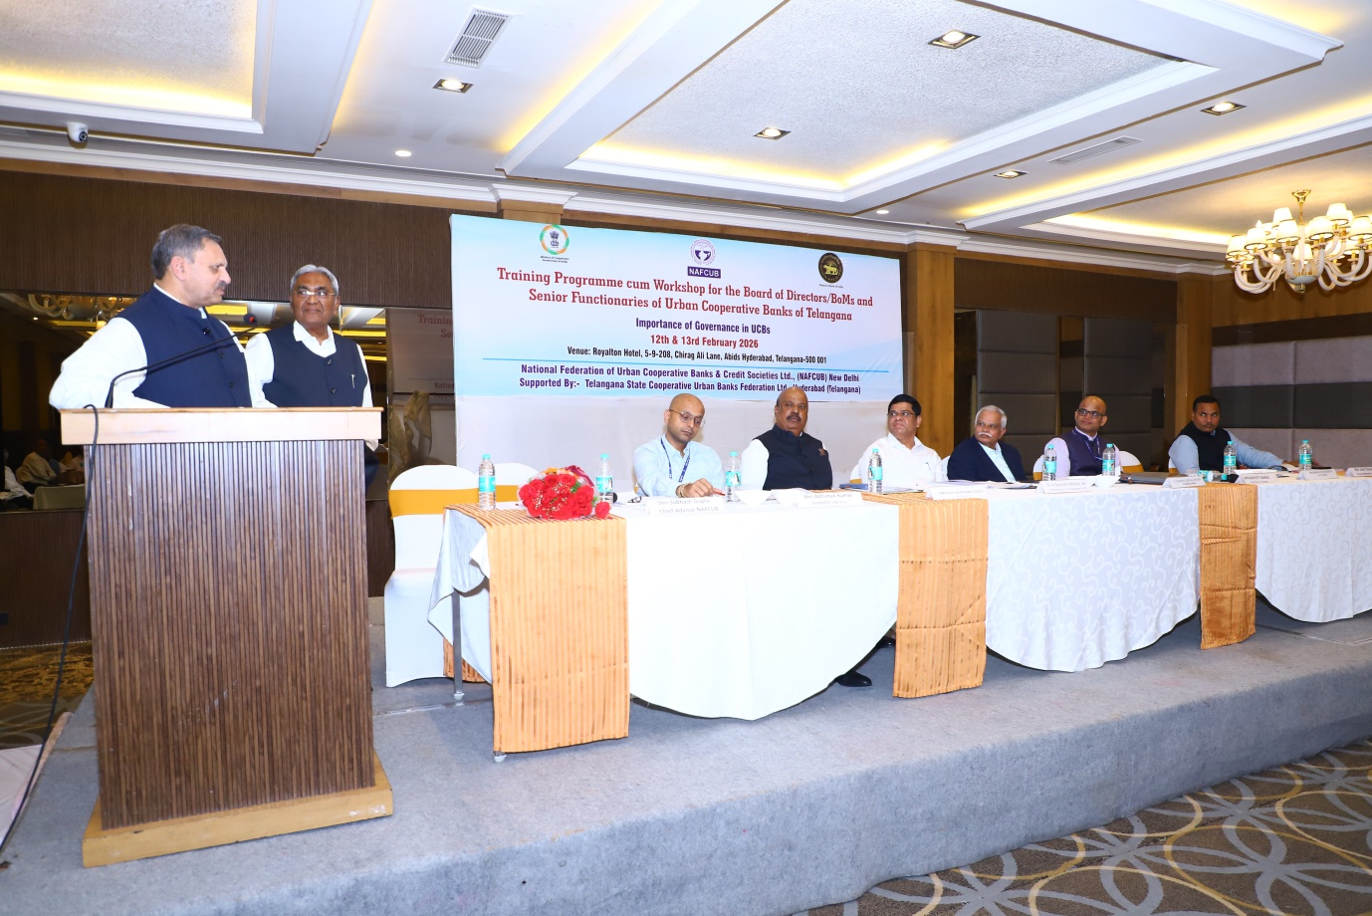
Shri Subhash Gupta thanking on behalf of NAFCUB

